EE313 ANALOG ELECTRONICS LABORATORY FINAL-REPORT
Mustafa Sefer DESTEGUL 2109973 Section: 03
DESIGN OF AN OPTİCAL WIRELESS COMMUNICATION SYSTEM: PHOTOPHONE
1.Introduction:
The photophone is a telecommunication device that allows transmission of speech on a beam of light. The communication method called Optical Wireless Communication allows us to transmit and receive the information via air. This communication form provides a very large band range like Khz and Ghz as well as low frequencies range like hz of electromagnetic spectrum to transmit and receive datas. I divided my pre-report into 2 parts as Transmitter and Receiver part not to be confused. We will first discuss the transmitter and then receiver part. Each part will be first mentioned briefly and after will go in detail.
2.TRANSMITTER
In this part, our aim is to transmit the information taken from the microphone to the receiver part successively. The figure 1 shows the transmitter part of the photophone. First, microphone signal will be obtained and converted into electrical signal and will be sent to band pass filter. Next the signal taken from filter will be added with carrier frequency (around 20 khz) with the help of summing amplifier. After that, since the information will be sent by the consideration of the current passing through a led, a current led driver will sent the infos to the receiver part. Let’s explain each part in detail, respectively.
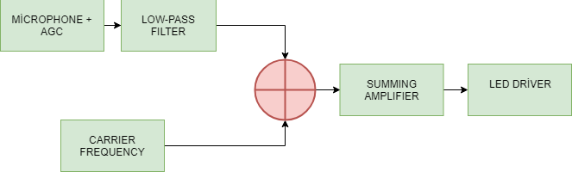
Figure 1: Transmitter part schematic of the photophone
2.1 Microphone and AGC : The Automatic Gain Control (AGC) amplifiers are another category of amplifiers which can vary its gain according to the input signal level. They provide enough amplification for the weak signals and prevent strong signals from getting over amplified. They apply very high gain whenever the signals are week and as the signal strength decreases, they automatically decrease their gain. Indeed, after describing our aim ,As we can see in figure 2 for a general purpose, this circuit is uses a two stage amplification of the signals, first with a simple transistor amplifier and then with an op-amp based AGC amplifier.
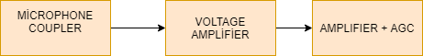
Figure 2: Schematics of Microphone and AGC part

2.1.1 Microphone coupler part: As can be seen in the fıgure 3 stage 1, microphone coupler is used to couple out the weak audio signals generated at the microphone. in this circuit a electret microphone is used which and the varying current is made to flow through a resistor across which the equivalent voltage get generated due to the current flow. This voltage across the resistor will be having a DC voltage on to which the varying voltage gets added up. This varying voltage is separated out from the DC voltage with the help of a coupling capacitor (0.1uF) and fed to the stage 2.
2.1.2 Voltage Amplifier: As can be seen in the fıgure 3 stage 2,this is an amplifier with a fixed gain and it is used to pre-amplify the audio signals from the microphone to the required level for the AGC amplifier circuit. a single transistor based amplifier circuit is used to amplify the audio signals coupled out from the microphone. This circuit is designed to have high gain so that the audio signals are get amplified enough. The quiescent voltage is adjusted as Vce= 5-(2200*1mA) = 2.8V. and the quiescent current is 1mA. After calculation of Q-Point, the gain is calculated as Av1= -gm*(2.2K// 1K)=0.0516*687.5 = -35.47 V/V. After the radio signal is amplified, it is fed to the stage 3.
2.1.3 Amplifier+ AGC: As can be seen in the fıgure 3 stage 3, This circuit uses a normal op-amp based negative feedback amplifier with an extra feedback network on its positive input pin. Normally the gain of a negative feedback amplifier is fixed by the feedback resistance on its negative input pin, but since this circuit has a feedback network connected to the positive input pin, the gain depends on that circuit also. The feedback network on the positive pin includes mainly a FET which acts like a voltage varying resistor, a transistor to drive that FET and a RC filter circuit that generates the varying gate voltage for the FET according to the varying signal strength at the output of the op-amp. If the voltage at the gate of the FET decreases it conducts less from ground to the positive input pin of the op-amp which increases the gain of the op-amp. When the voltage at the gate of the FET increases it conducts more and hence reduces the gain. The gain will be at the maximum at that time when the gate voltage of the FET will be very small and it will not conduct from ground to the positive pin of the op-amp and can be found out using the following equation:
AV2 = - ( R2 / R1 ) dB = - 47K/ 1K = -47 dB

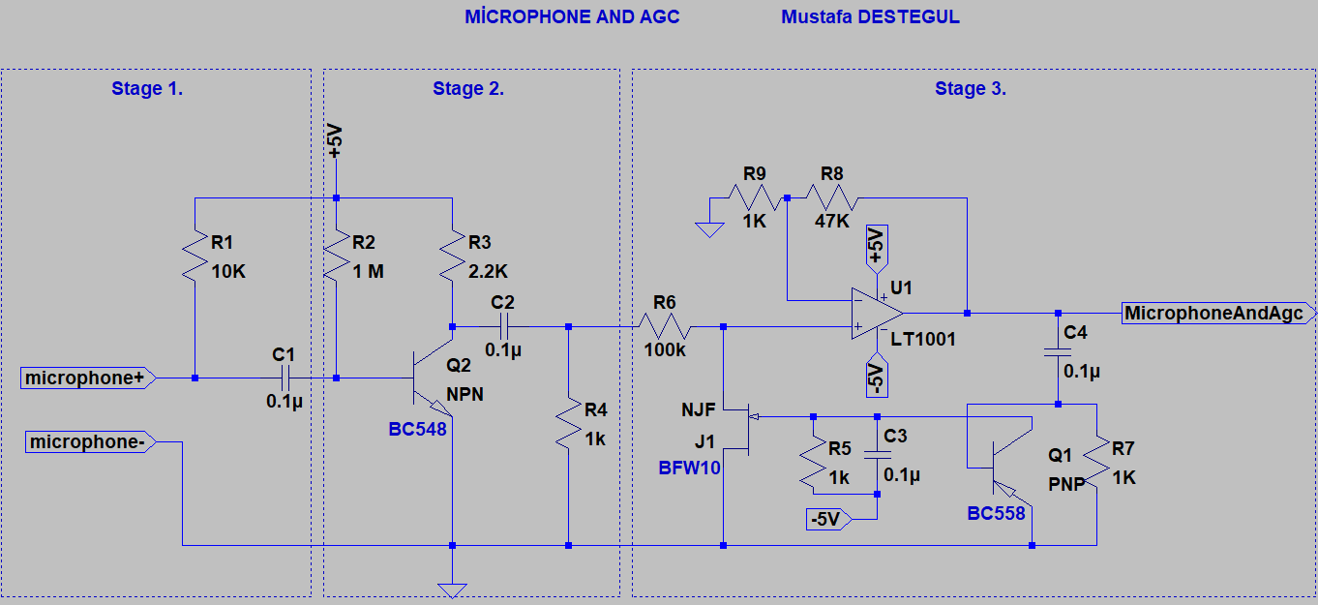
Figure 3: Microphone+ AGC circuit schematics
Comments on discrepancies: The figure 4 shows the LTSpice output of the circuit in Figure 3. Although the input voltage is changed at a considerable level the output response is almost the same and works perfectly, but the magnitute of gain is different according to the theoretical calculations. It is supposed that the difference can result form the FET transistors since there is no BFW10 in LTSpice. As we come to the experience results , the non-ideality of the exact components values of the circuit affected the results very much and as a result of that , the circuit didn’t work well.
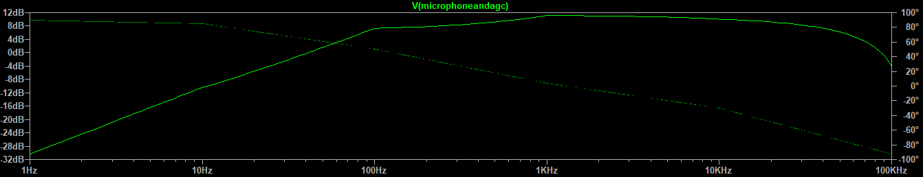
Figure 4: Output response of the microphone+ AGC circuit in Figure 3 with input voltage 0.01V and 5V.

2.2 Low-Pass Filter: Since narrowband telephony only uses the portion of 300 Hz to 3.4 kHz, it is decided that a band pass filter should be used so as to aliminate the low frequency noises and higher frequencies above 3.4 khz. The upper limit of the 3-db cutoff frequency should be arranged as around 3.4 khz so that this frequency doesn’t overlap with the carrier frequency if it is increased more since filters are not ideal. Sınce the transmitter part doesn’t need to have a sharper frequency response , only eliminating above 3.4 khz, a simple two RC circuit with a op-amp ,to have some gain , is used.The input obtaining from the microphone + AGC part is first a high pass and after amplified it is fed to the low pass filter. After this opration the band pass filter is obtained. The lower cut-off frequency of the filter is theoretically calculated as F=1/(2*pi*R2*C2) = 300 and C2 is chosen as 47 nF. After this calculation R2= 11.2k is found. For he upper cut-off frequency ,3.4 khz,, from the formula F=1/(2*pi*R1*C1) and C1=47 nF, R1= 996 ohm is found.
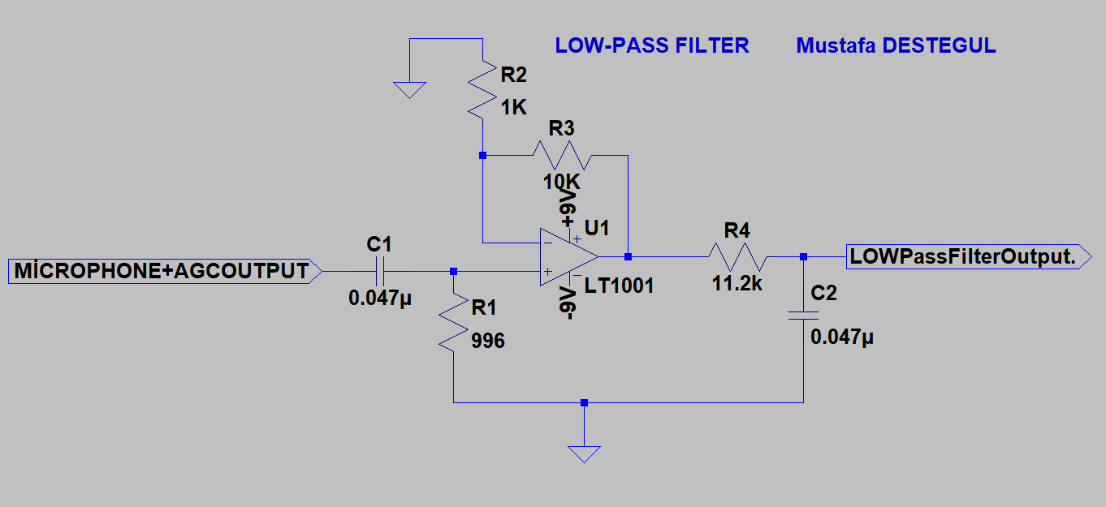
Figure 5 : Schematics for the low pass filter for the transmitter part
The output response of this band pass filter is demonstrated in Figure 6. As expected, the signal passes between 300 hz and 3.4 khz according to 3 db cut- off frequency, and stops outside this frequencies which is stop-band.
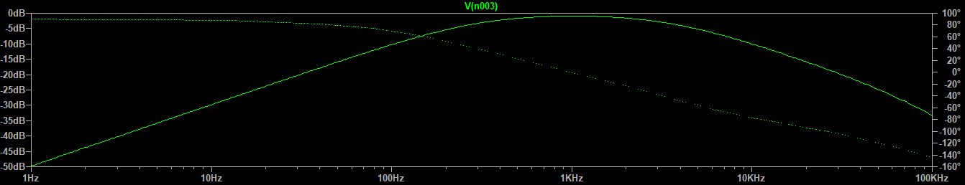
Figure 6 : Output response of the band pass filter between 300 hz and 3.4 khz.
Comments on discrepancies: As an approximation R2= 11k and R1=1k is chosen. The experimental result was almost the same as theoretical result except the lower cut off frequency was a little bit low like 150 hz. To increase this, R2 resistor is decreased to 8.2 k with the help of a 10 k potansiometer.
2.3 Carrier Frequency: The purpose of the carrier is to transmit the information through space as an electromagnetic wave (as in radio communication), and allow several carriers at different frequencies to share a common physical transmission medium. Also a constant term will be given with the frequency to measure the signal strength. In this experiment a 20 khz signal generator is used to transmit the radio wave.
2.4 Summing Amplifier: The purpose of summing amplifier is modulating two signal and give modulated signal as output. We have an operational amplifier circuit that will amplify each individual input voltage and produce an output voltage signal that is proportional to the algebraic “SUM” of the two individual input voltages V_{carrier} and Vband pass. The output of the amplifier is Vout=- R1/R2 * Vcarrier –R1/R2 *Vbandpass.
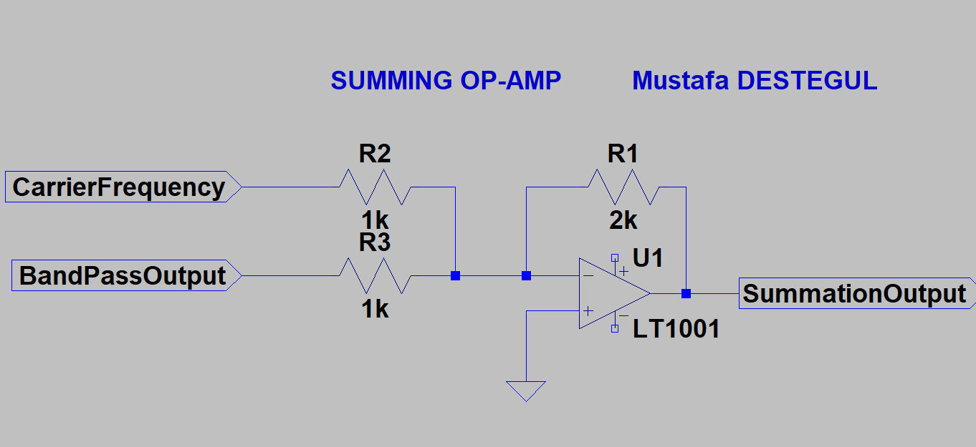
Figure 7: Summing amplifier circuit diagram.
The experimental and theoretical results are the same, no change was observed.

2.5 Led Driver: audio signal will be sent by just adjusting the current intensity of the led ,so led driver should be a current sensitive driver as the light output equates proportionally to the drive current, not to the drive voltage. To do so, a transconductance amplifier is needed as the audio signal will be current sensitive and this amplifier converts voltage in the input side to currents at the output side. Also, since the led needs a constant dc voltage to be driven, either a common collector transistor or a constant dc voltage in the summation part will be needed. In this experiment a commen emitter amplifier is used to transmit data via a red led as can be seen from the figure 9. To eliminate the DC voltage compenent a capacitor is used. The transistor is biased through the R1-POT and R4 resistors and be sure about the transistor biased well. The 10K POT is used to adjust the brightness of the led. When we decreased the pot value it is realized that the brigtness of the led is increased, However, it is undesired issue since it will be hard to sense for the phototransistor when we increased brightness.Therefore , it is lowered as possible as.

Figure 8:Schematics of Led Driver Part
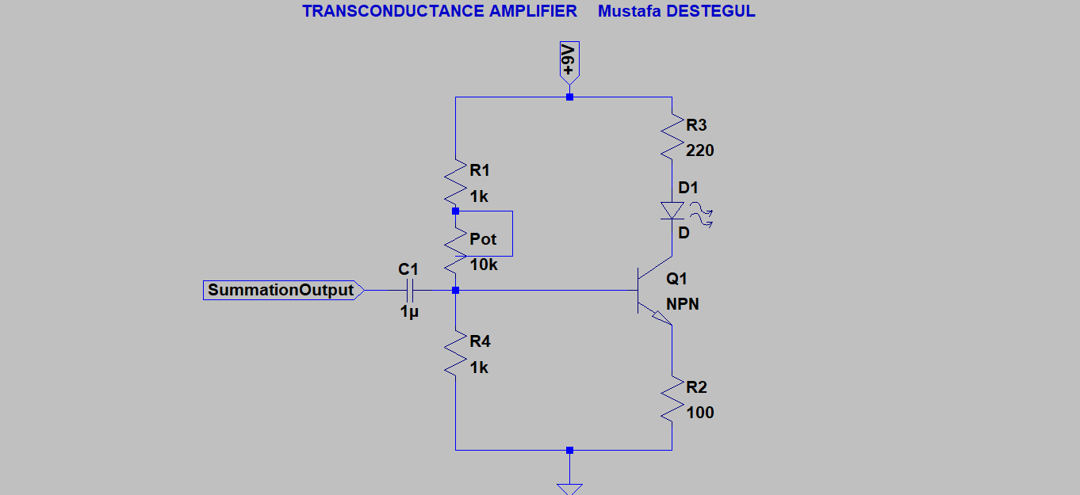
Figure 9 : Schematics for the led driver circuit.

3. RECEIVER
In this part, our aim is to receive the summed signal from the transmitting part as light intensity. Figure 10 shows the receiver part of the photo-phone. By the help of the optical receiver module, the signal will be separated to main part as low frequency part and high frequency part. Low frequency part is the part the audio signal will be separated from the summed received signal in optical receiver module. It will be separated by the help of the band filter from high frequency part. After that the signals power should be increased by the power amplifier to drive the speaker which will have 1 watt power and quality sound at the output. On the other hand, the received signal also needed to be passed through the band pass filter to obtain the high frequency carrier frequency. After obtaining the high frequency carrier signal, it will be sent to the RGB driver which is basicly a window comparator circuit. Then with some diode arrangement 5 different color will be obtained at the RGB led.
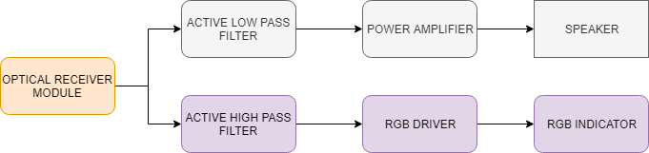
Figure 10: Receiver part diagram Photo-phone
3.1 Optical Receiver Module: Since the electromagnetic wave will be sent via air , we need a light sensitive sensor to capture the waves. As can be seen from the figure 5, a phototransistor is chosen for this purpose. The reason is that photodiodes is ideal for very fast signals but gives a much lower output signal, but phototransistor provides an amplified signal output and the signals studied tend to be relatively slow which is acceptable in our frequency range. Also, since photodiode should be used in reverse active mode, it is a little bit hard to be kept in reverse active mode compared to phototransistors which is only wants bias voltage to operate. After sensing the current with the help of the phototransistor, the signal should be converted to voltage to operate on it. In this stage, a trans-resistance amplifier is just what we need since a trans-resistance amplifier converts current in the input to voltage at the output. As can be seen from the figure 12, the obtaining current density from the phototransistor is fed to the amplifier from the inverting input and non-inverting input of the amplifier is biased to operate in linear region and by the help of the LM741 amplifier it is amplified since the signal is low at the input side.After obtaining the mixed signal, it will be sent to high and low pass filter.

Figure 11 : Schematics of the Sensing Unit in the receiver part
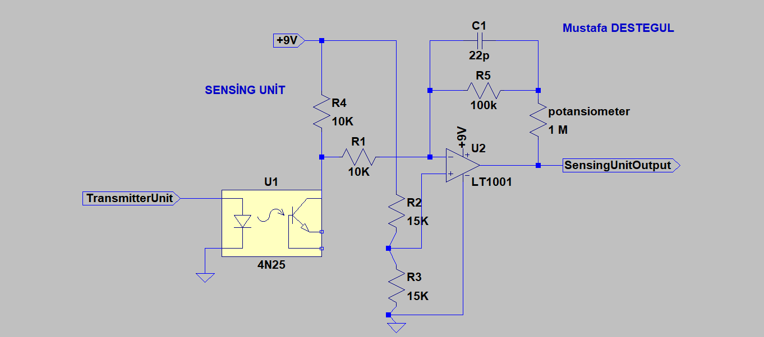
Figure 12: The circuit schematics for the sensing unit.
3.2.1 Low-pass Filter: As can be seen from the figure 13 , After taking our mixed signal from the trans-resistance amplifier, the low frequency audio signal should be separated from the high carrier frequency by a band pass filter filtering the signals in the range of 300 hz and 3.4 khz to have the created audio signal in the microphone.. To do this operation, the signal is first passed through a high pass filter made by a RC circuit to clip the signals bigger than 3.4 khz and then the signal is amplified by a amplifer as in figure 5 in section 2.2. Next the signal is sent to a low pass filter made by a RC circuit to prevent the signals lower than 300 hz since in the output of the transresistance amplifier consist of the daily light (noise) as well. According to experimental results, it worked well. However, upper 3-dB cut off frequency is approximated as 10 khz. After this frequency no signal is passed and this is okay for our needs.
3.2.2 Power amplifier: After filtering operation, the signal is sent to the power amplifier to drive the speaker. LM386N is a quite a versatile chip to make an audio amplifier with an output power of 1W. Actually, the output power also depends on speaker impedance and supply voltage . A 8ohm speaker and 9V supply voltage is chosen. Gain is the amplification of the input potential and is a characteristic of the amplifier. Volume lets us adjust the sound level within the range of amplification set by the gain. Gain sets the range of possible volume levels. For example, if gain is set to 20, the range of volume is 0 to 20. If gain is set to 200, the range of volume is 0 to 200. As can be seen from the figure 14 lm386 pinout diagram ,the volume control can be achieved by connecting a capacitor between 1 and 8 pin and a serial adjusted potansiometer series with that capacitor as can be seen from the figure 15.According to the datasheet of LM386N, without a capacıtor the gain will be set to 20.However with a 10uF capacitor it will be set to 200 and this is chosen since we need some gain to amplify input signal.By adding a potansiometer with this capacitor, the gain can be adjusted and as a result volume as well. After some researches it is noticed that it would be better if the noise is prevented with the help of the capacıtors and distortion too. Therefore , 100 μF and 0.1 μF capacitors is connected between the positive and negative power rails to decouple the power supply. The 100 μF capacitor will filter low frequency noise while the 0.1 μF capacitor will filter high frequency noise.Additionally A 0.1 μF capacitor between pins 4 and 6, is for additional decoupling of the power supply to the chip and A 10K Ohm resistor and a 10 μF capacitor in series between pin 7 and ground to decouple the audio input signal .

Figure 13: Schematics of The output stage 1
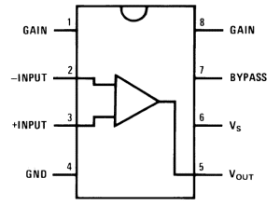
Figure 14: The pin-out diagram of LM386N
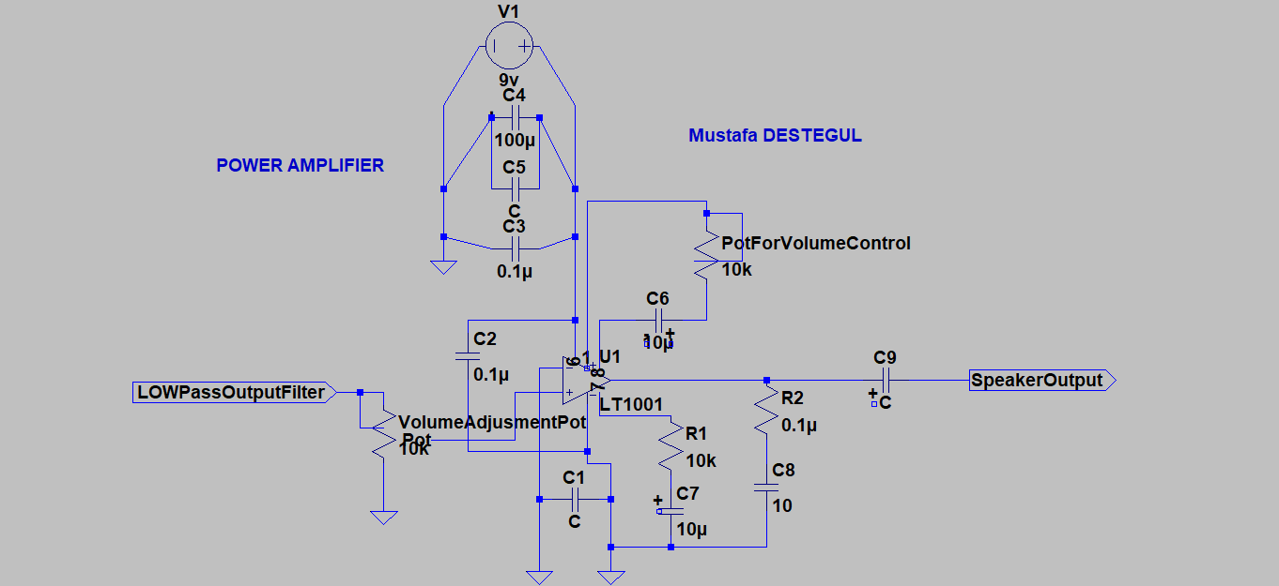
Figure 15: The schematics of Power amplifier

3.3.1 High-pass Filter: we need to separate our high frequency carrier signal from the output of the trans-resistance output since we want to indicate that our signal strength when the transmitter part is getting far away from the receiver part and show the level of signal with colors. The figure 16 shows how we will proceed the color indication of the signal. To do this, After taking our mixed signal from the trans-resistance amplifier, the high frequency carrier signal should be separated from the low audio frequency signal by a band pass filter filtering the signals in the range of 15 khz and 25 khz. To do this operation the circuit with the same logic with low-pass fılter is established like in figure 17., the signal is first passed through a high pass filter made by a RC circuit to clip the signals bigger than 25 khz and then the signal is amplified by a amplifier. Next the signal is sent to a low pass filter made by a RC circuit to prevent the signals lower than 15 khz. The resistors and capacitor values are arranged according to the formula of F= 1/(2* Pİ*R*C)We want our upper cut-off frequency to be about 15 khz. For this purpose F=15 khz=1( 2*pi*R1*C1), and C1 is chosen as 47 nF. According to this formula, R1= 135 ohms. And with the same way, C2= 47 nF and R2=225 ohms for the lower cut-off frequency. The result is shown in figure 18. According to that response, the lower 3 dB cut off frequency is about 12 khz and higher 3 dB cut-off frequency is about 50 khz. Although the upper cut off frequency is high, it can be implemented for our purposes since it doesn’t affect our results for the high frequencies. However the lower cut off frequency is about 12 khz and this created a big problem like collapsing with the low frequency levels since frequency response is not enough sharper as can be seen from the figure 18., Indeed, the band-pass filter for the high frequency responses passed our low frequency audio signal coming from the microphone. This can be solved by establishing a higher order butterwoth fılter since this filters have a sharper responses and have a better Q( Quality factor). I couldn’t set up this filter because of lack of time for the lab schedule.However this problem can be overcomed in this way.
Comments: as stated above for the hıgher 3 dB cut off frequency, no problem is observed since it is okay for us whether the upper frequency level is bigger than 50 khz or not. In this experiment the important one is the lower 3dB cut off frequency and in my circuit it created a big problem for me since it passed the audio signal as well.
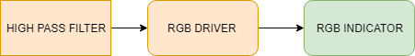
Figure 16: Schematics of The Output Stage 2

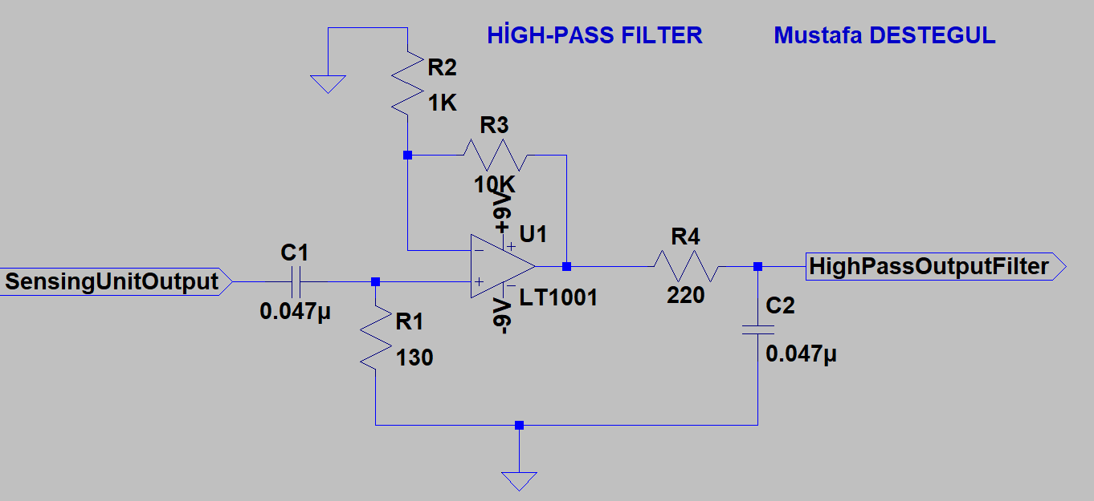
Figure 17: High pass circuit schematic
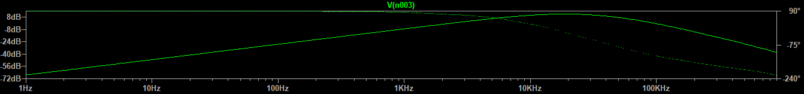
Figure 18. Frequency response of the high pass fılter.
3.3.2. RGB driver: After filtering operation, the mission is, according to 5 different signal level coming from the carrier signal, 5 different color will appear at the RGB led. To make it happen, a RGB led driver is established by the help of the window comparator like in figure 19. This comparator will compare 5 different signal according to a reference signal and in each state one output will be logic high ,5V, when the others will be logic low ,0V,. The carrier frequency signal is chosen as 7 V peak to peak and every resistor is chosen as 1k to have incremental voltage drop for each op-amp input. For example when the transmitter part is very close to the receiver part, a 7V drop will be obtained from the high pass output and U2-U3-U4-U5 will give 0V output but U1’s output will be 5 V and RED light will be lightened, and , if the transmitter part is far away from the receiver part the signal level will be 1v or lower. In this case, while U5’s output is 5V the others will be 0V and ORANGE will be lightened. In experiment , at the beginning, 3 different color is obtained since the resistors and op-amps are not ideal and voltage differences were different at each op-amps comparator input. However when the carrier signals output increased and after some arrangement of resistors 4 different RGB output is obtained. The last RGB couldn’t be lightened since the voltage dropping on R2 resistor is not the same with the theory.
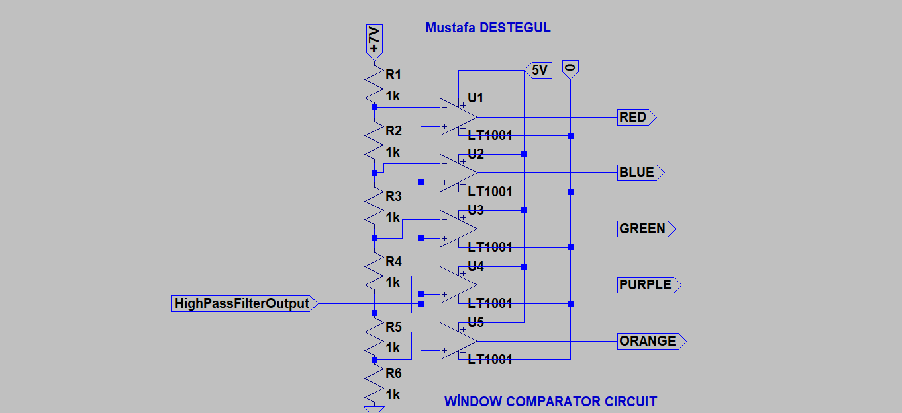
Figure 19: The circuit schematic of the RGB driver part.
3.3.3: RGB indicator: Since RGB led has 3 different color on it, two more color (purple and orange) are needed. For this purpose, first the output of the window comparator is connected a RGB indicator circuit as can be seen in figure 20. Since the diodes are the components which passes current just through one side, by adjusting the diodes directions 2 more color is obtained. According to this, to turn the speaker off a relay can be established so that the reference signal is low , the speaker goes short circuit with ground. For this purpose, when U5’s output is active relay connected to the speaker is opened and the speakers positive input goes to ground and the speaker is short circuited.
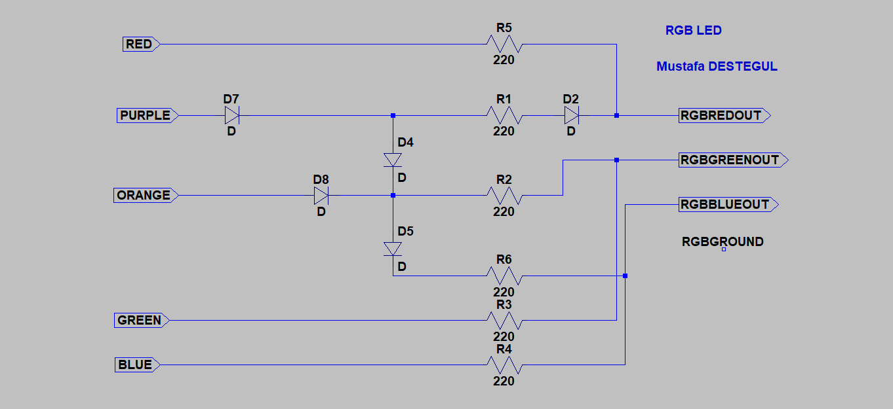 Figure 20: Schematics of the Diode Connections.

